Carbohydrates metabolism
Metabolism is the chemical reactions in the body's cells that change food into energy. There are different metabolic pathways in cells that break down fuel molecules to transfer their energy into high energy compounds through respiration. These high energy compounds include:
- Adenosine triphosphate (ATP)
- Guanosine triphosphate (GTP),
- Reduced nicotinamide adenine dinucleotide (NADH)
- Reduced flavin adenine dinucleotide (FADH₂)
- Reduced nicotinamide adenine dinucleotide phosphate (NADPH).

In carbohydrate metabolism, the breakdown starts from digestion of food in the gastrointestinal tract and is followed by absorption of carbohydrate components by the enterocytes in the form of monosaccharides.
Monosaccharides are transferred to cells for aerobic and anaerobic respiration via glycolysis, citric acid cycle and pentose phosphate pathway to be used in the starvation state. In the normal state, the skeletal muscle and liver cells store monosaccharides in the form of glycogen.
In the obesity state, the extra glucose is converted to triglycerides via lipogenesis and is stored in the lipid droplets of adipocytes.
In the lipotoxicity state, the lipid droplets of other tissues such as the liver, skeletal muscle and pancreatic beta cells also accumulate triacylglycerol.

Glycolysis
Glycolysis is the process in which glucose is broken down to produce energy. It produces two molecules of pyruvate, ATP, nicotinamide adenine dinucleotide (NAD) + hydrogen (NADH) and water. The process takes place in the cytoplasm of a cell and does not require oxygen. It occurs in both aerobic and anaerobic organisms.
Glycolysis has two phases: the investment phase and the payoff phase. The investment phase is whlkbnwsere there is energy, as ATP, is put in, and the payoff phase is where the net creation of ATP and NADH molecules occurs. A total of 2 ATP goes in the investment phase, with the production of 4 ATP resulting in the payoff phase; thus, there is a net total of 2 ATP. The steps by which new ATP is created has the name of substrate-level phosphorylation.

Glycolysis Pathway
The glycolysis pathway occurs in the following stages:
Stage 1. A phosphate group is added to glucose in the cell cytoplasm, by the action of enzyme hexokinase. In this, a phosphate group is transferred from ATP to glucose forming glucose,6-phosphate.
Stage 2. Glucose-6-phosphate is isomerised into fructose,6-phosphate by the enzyme phosphoglucomutase.
Stage 3. The other ATP molecule transfers a phosphate group to fructose 6-phosphate and converts it into fructose 1,6-bisphosphate by the action of the enzyme phosphofructokinase.
Stage 4. The enzyme aldolase converts fructose 1,6-bisphosphate into glyceraldehyde 3-phosphate and dihydroxyacetone phosphate, which are isomers of each other.
Step 5. Triose-phosphate isomerase converts dihydroxyacetone phosphate into glyceraldehyde 3-phosphate which is the substrate in the successive step of glycolysis.

Step 6. This step undergoes two reactions:
The enzyme glyceraldehyde 3-phosphate dehydrogenase transfers 1 hydrogen molecule from glyceraldehyde phosphate to nicotinamide adenine dinucleotide (NAD⁺) to form NADH + H⁺. Glyceraldehyde 3-phosphate dehydrogenase adds a phosphate to the oxidised glyceraldehyde phosphate to form 1,3-bisphosphoglycerate.
Step 7. Phosphate is transferred from 1,3-bisphosphoglycerate to ADP to form ATP with the help of phosphoglycerokinase. Thus, two molecules of phosphoglycerate and ATP are obtained at the end of this reaction.
Step 8. The phosphate of both the phosphoglycerate molecules is relocated from the third to the second carbon to yield two molecules of 2-phosphoglycerate by the enzyme phosphoglyceromutase.
Step 9. The enzyme enolase removes a water molecule from 2-phosphoglycerate to form phosphoenolpyruvate.
Step 10. A phosphate from phosphoenolpyruvate is transferred to ADP to form pyruvate and ATP by the action of pyruvate kinase. Two molecules of pyruvate and ATP are obtained as the end products.

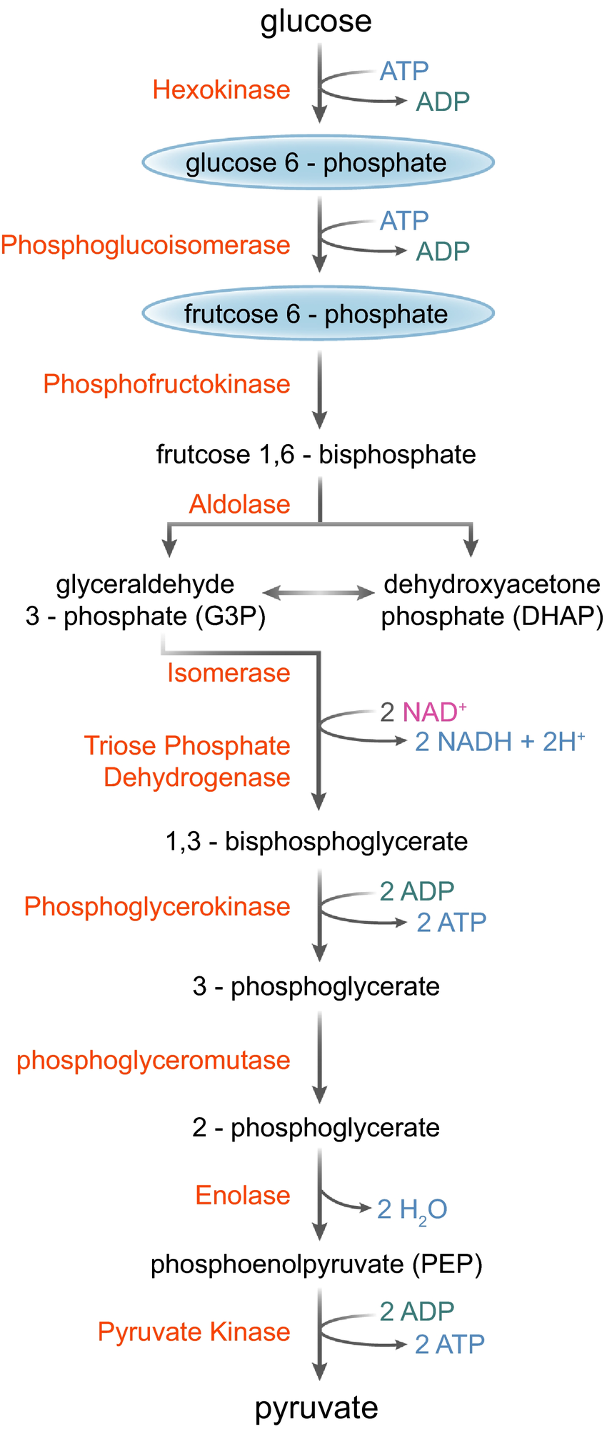
k
Glycolysis pathway

Summary

Stages of Glycolysis The glycolytic pathway can be divided into two main phases: the investment phase and the yield phase.
- Investment Phase
  - Step 1: Phosphorylation of Glucose
    - Enzyme: Hexokinase
    - Reaction: Glucose is phosphorylated using one ATP molecule to form glucose-6-phosphate (G6P).
  - Step 2: Isomerization
    - Enzyme: Phosphoglucose Isomerase
    - Reaction: G6P is rearranged into fructose-6-phosphate (F6P).
  - Step 3: Second Phosphorylation
    - Enzyme: Phosphofructokinase (PFK-1)
    - Reaction: Another ATP molecule is used to convert F6P into fructose-1,6-bisphosphate (F1,6BP).
  - Step 4: Cleavage
    - Enzyme: Aldolase
    - Reaction: F1,6BP is split into two three-carbon molecules: glyceraldehyde-3-phosphate (G3P) and dihydroxyacetone phosphate (DHAP).
  - Step 5: Isomerization of DHAP
    - Enzyme: Triose Phosphate Isomerase
    - Reaction: DHAP is converted into G3P, resulting in two molecules of G3P available for subsequent steps.
- Yield Phase Each G3P undergoes further reactions:
  - Step 6: Oxidation and Phosphate Addition
  - oxidation – transfer of electrons chemically
    - Enzyme: Glyceraldehyde-3-phosphate Dehydrogenase
    - Reaction: G3P is oxidized, reducing NAD+ to NADH and adding an inorganic phosphate to form 1,3-bisphosphoglycerate (1,3-BPG).
  - Step 7: Substrate-Level Phosphorylation
    - Enzyme: Phosphoglycerate Kinase
    - Reaction: A phosphate group from 1,3-BPG is transferred to ADP to produce ATP and 3-phosphoglycerate (3-PG). [energy yield]
  - Step 8: Isomerization
    - Enzyme: Phosphoglycerate Mutase
    - Reaction: 3-PG is converted into 2-phosphoglycerate (2-PG).
  - Step 9: Dehydration
    - Enzyme: Enolase
    - Reaction: Water is removed from 2-PG to form phosphoenolpyruvate (PEP).
  - Step 10: Final Substrate-Level Phosphorylation
    - Enzyme: Pyruvate Kinase
    - Reaction: PEP donates its phosphate group to ADP, forming another ATP molecule and yielding pyruvate.
Overall Yield of Glycolysis From one molecule of glucose, glycolysis produces:
- Net Gain of ATP = 2 ATP molecules (4 produced – 2 consumed)
- Net Gain of NADH = 2 NADH molecules
- End Product = 2 Pyruvate molecules
Importance of Glycolysis Glycolysis plays a crucial role in cellular metabolism:
- It provides energy quickly under anaerobic conditions.
- It serves as a precursor for further metabolic pathways such as the Krebs cycle during aerobic respiration.
- It generates intermediates that can be utilized for biosynthesis.
Regulation of Glycolysis Key regulatory enzymes include:
- Hexokinase/Glucokinase – regulated by glucose levels.
- Phosphofructokinase – regulated by ATP levels; high ATP inhibits while AMP activates it.
- Pyruvate Kinase – regulated by fructose-1,6-bisphosphate which activates it.

Key Points of Glycolysis
- It is the process in which a glucose molecule is broken down into two molecules of pyruvate.
- The process takes place in the cytoplasm of plant and animal cells.
- Six enzymes are involved in the process.
- The end products of the reaction include 2 pyruvate, 2 ATP and 2 Nicotinamide adenine dinucleotide (NADH) molecules.
- NADH stands for "nicotinamide adenine dinucleotide (NAD) + hydrogen (H).
- Nicotinamide adenine dinucleotide (NAD +) is a co-enzyme that plays a key role in the process of glycolysis
- NAD exists in two forms: an oxidized and reduced form, abbreviated as NAD+ and NADH (H for hydrogen), respectively.
- NAD is called a dinucleotide because it consists of two nucleotides joined through their phosphate groups. One nucleotide contains an adenine nucleobase and the other, nicotinamide.
- In cellular metabolism, NAD is involved in redox reactions, carrying electrons from one reaction to another, so it is found in two forms: NAD+ is an oxidizing agent, accepting electrons from other molecules and becoming reduced; with H+, this reaction forms NADH, which can be used as a reducing agent to donate electrons.

Clinical significance of glycolysis
- Pyruvate kinase deficiency is an autosomal recessive mutation that causes hemolytic anemia.
- Energy Production: Glycolysis is a key metabolic pathway for generating ATP, the primary energy currency of cells.
- Cancer Metabolism: Dysregulated glycolysis is often observed in cancer cells, supporting their rapid growth and proliferation.
- Diabetes: Impaired glycolysis contributes to elevated blood glucose levels in diabetes and is implicated in disease progression.
- Neurodegenerative Diseases: Dysfunctional glycolysis is linked to neuronal dysfunction and neurodegeneration in diseases like Alzheimer's and Parkinson's.
- Infectious Diseases: Pathogens can exploit host glycolysis for their energy needs, offering potential targets for antimicrobial therapies.
- Ischemic Injury: Glycolysis becomes crucial for ATP production during ischemic conditions, influencing cellular survival and tissue damage.
- Diagnostic Biomarkers: Altered glycolytic activity can serve as diagnostic markers, detected through techniques like PET scans in cancer diagnosis.

